PARAS Grammar School – First Term Exam
Course Title | Computer Science | Instructor/s | Mr. Aoun Haider
Class | 7th | Syllabus | Chapter 1, 3
Time Allowed | 2 hour | Date |  | Total Marks | 50
Student Name |  | Roll No
Important Instructions/Guidelines:
- Attempt all the questions
- Cutting/overwriting is not allowed
- Return the question paper along with your answer sheet
Q#02: Attempt any five short questions: [2x5 = 10 Marks]
1. Differentiate between random algorithm and sorting algorithm.
2. Define Algorithm.
3. Explain Webcam with an example.
4. What is computational thinking?
5. Differentiate between Mouse and Keyboard.
6. Differentiate between Abstraction and Generalization.
7. Define Augmented Reality.
8. Differentiate between keyboard and scanner.
Q#03: Attempt any two long questions: [5x2 = 10 Marks]
1. Write an algorithm to add three numbers.
2. What are rules of drawing flowchart?
3. What is port? Explain any four types of computer ports.
(Ali Raza bad near Ali Town Station Lahore)
Q#01: Mark the correct option. [0.5x10 = 5 Marks]
- Solve a problem in a diagrammatic way
- Generalization | - Abstraction
- Algorithm | - Flowchart
- Monitor is an
- Output device | - Computing device
- Input device | - None of these
- Loops can be
- Infinite loops | - Finite loops
- Both (a) and (b) | - None of these
- The algorithm which goes through all possible solutions until required solution is found
- Generalization | - Deconstruction
- Pattern Recognition | - Design
- Discover the principles that cause the patterns of a problem is called
- Expansion port | - Keyboard
- Graphic card | - Express port
- GPU is added in computer using
- SATA | - USB
- PCIe | - HDMI
- A three-dimensional image created with projection is called
- Telegram | - Hologram
- Histogram | - Photogram
- USB stands for
- Unique series bus | - Universal state bus
- Unique state bus | - Universal Serial bus
- Resolution is property of
- Keyboard | - Scanner
- Webcam | - Mouse
- Express port is also known as
- Expansion port | - SATA port
- PCIe port | - Type-C port

Q#05: Draw flowchart for the given algorithm: [1x5 = 5 Marks]

1. START
2. Declare three integer variables num1, num2
3. Input the value in num1, num2
4. If num1 is less than num2, then print 'num1 is minimum' and go to step no. 6
5. Print 'num2 is minimum'
6. END

Q#04: Identify T/F among the following: [1x5 = 5 Marks]
1. Every flowchart has a decision node.
2. We divide the problem into smaller one in decomposition.
3. GPU is added to the computer using SATA port.
4. Algorithm helps us to solve a problem.
5. Hovering and Scrolling are same in mouse movement.

Q#06: Label function keys, control keys, numeric keys, navigation keys, typing keys in the given QWERTY standard keyboard layout [1x5 = 5 Marks]
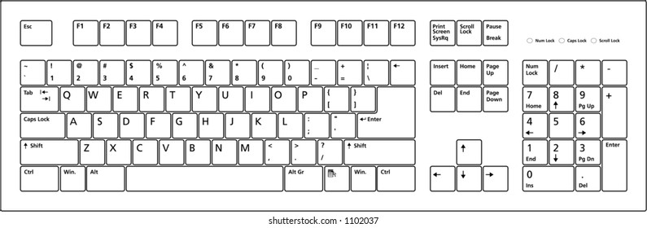

Q#07: Write the name of the given flowchart symbol: [1x5 = 5 Marks]
Q#08: Identify mode of mouse used among [select, drag and drop, hovering, scrolling, double click, move pointer]: [1x5 = 5 Marks]
You double-click a desktop icon to launch a game.
You press and hold the left mouse button to move a file from one folder to another.
You hover over a menu to see additional submenu options appear.
You scroll up on a webpage to return to the top of the article.
You double-click a text document to open it in a word processor.

